Copyright for test papers and marking guides remains with *West Australian Test Papers.*

Test papers may only be reproduced within the purchasing school according to the advertised Conditions of Sale.

Test papers should be withdrawn after use and stored securely in the school until Friday, 1 December 2017.



**SEMESTER TWO**

**MATHEMATICS**

**METHODS**

**UNITS 1 and 2**

**2017**

**SOLUTIONS**

***Calculator−free Solutions***

1. Origin is at (2, 8)

Radius = 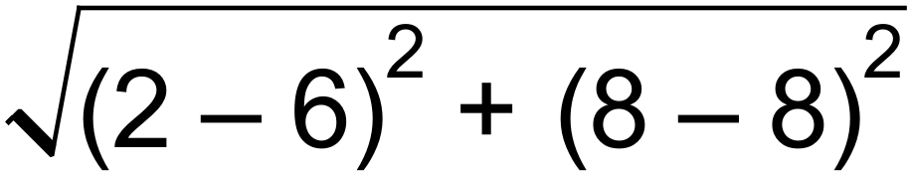

= 4 ✓

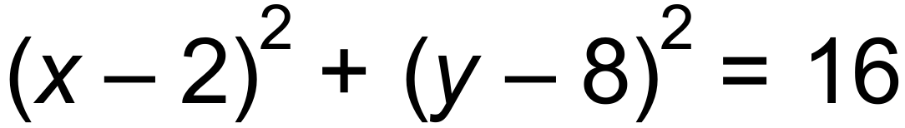 ✓ [2]

2. (a) 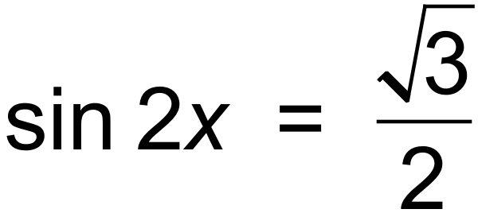 ✓

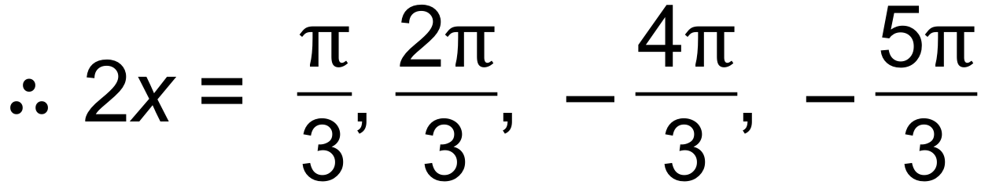 ✓

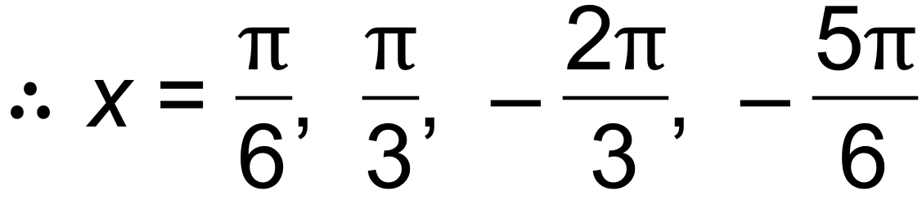 ✓

(b) cos *x* cannot be more than 1. ✓ [4]

3. (a) 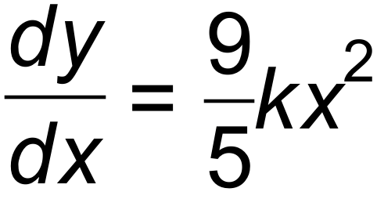 ✓✓

(b) 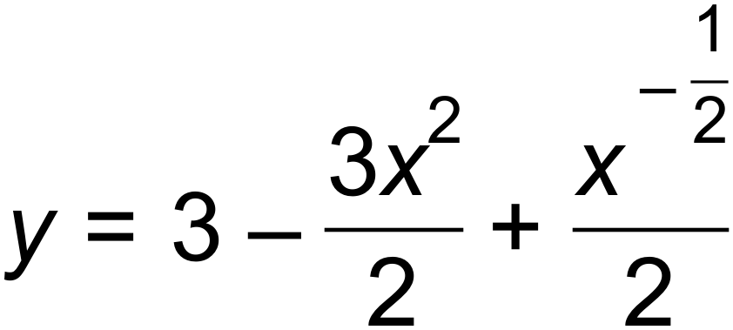 ✓

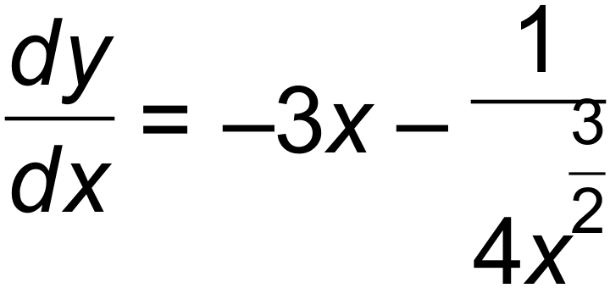 ✓✓

(c) 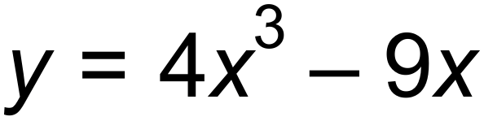 ✓

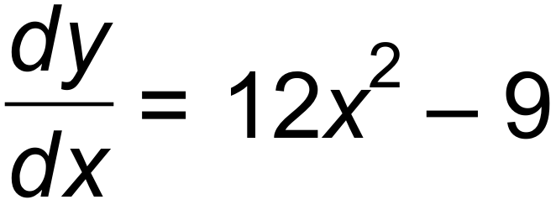 ✓ [7]

|  |  |  |  |
| --- | --- | --- | --- |
|  |  |  |  |
| D | A | B | C |

4.

✓✓✓✓ [4]

5. (a) (i) 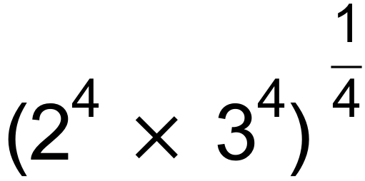

= 6 ✓

(ii) 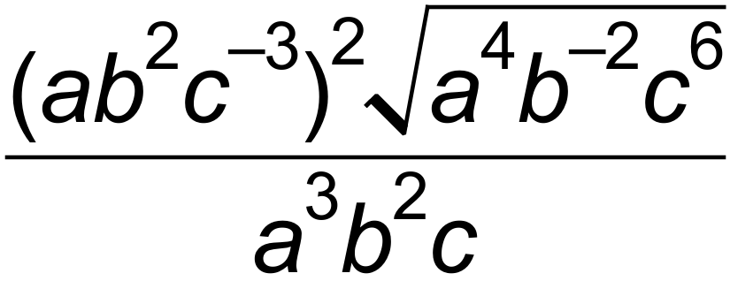

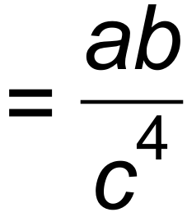 ✓✓

(iii) 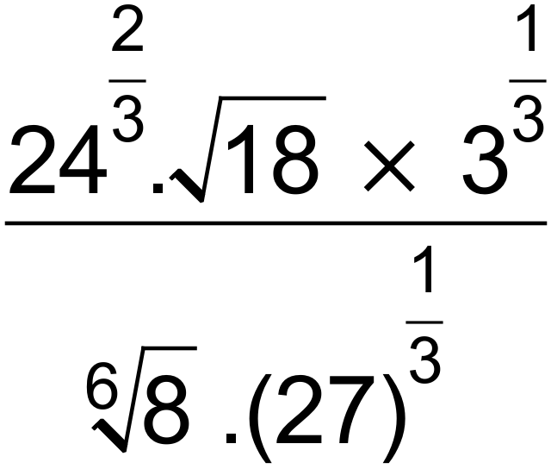

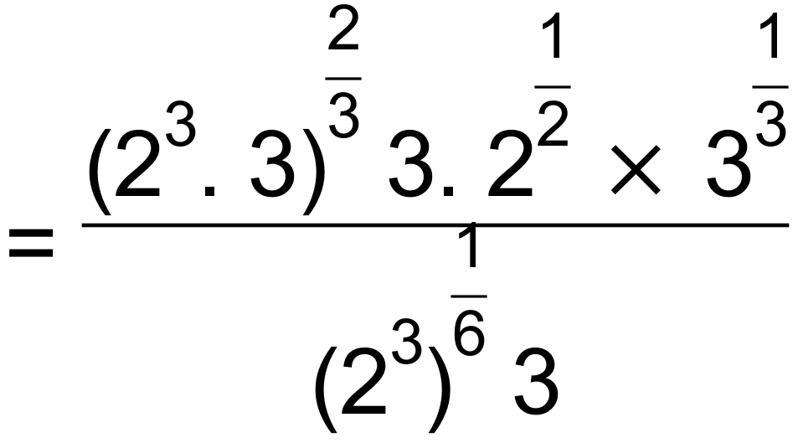 ✓✓

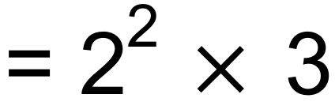

= 12 ✓

(b) (i) 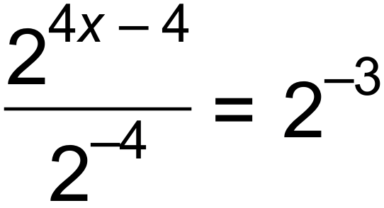 ✓

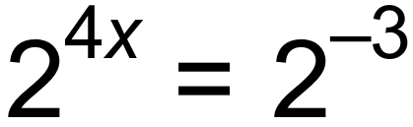 ✓

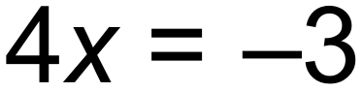

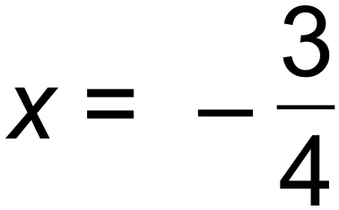 ✓

(ii) 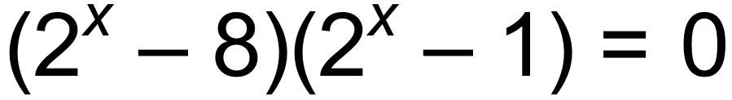

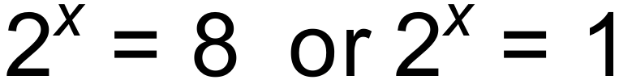 ✓

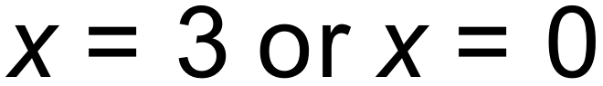 ✓ [11]

6. (a) (i) 0.2 ✓

(ii) 0.4 ✓

(iii) 0.7 ✓

(b) 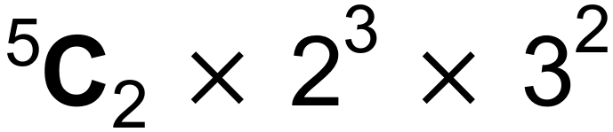 = 720 ✓✓ [5]

7. (a) (i) 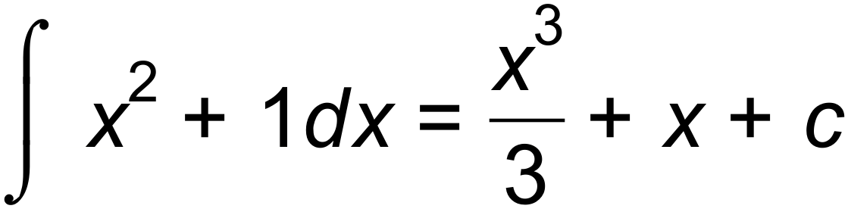 ✓✓

(ii) 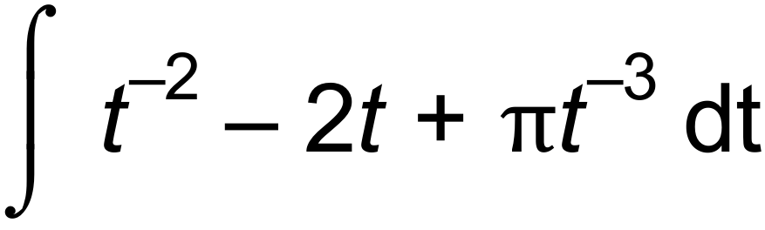 ✓

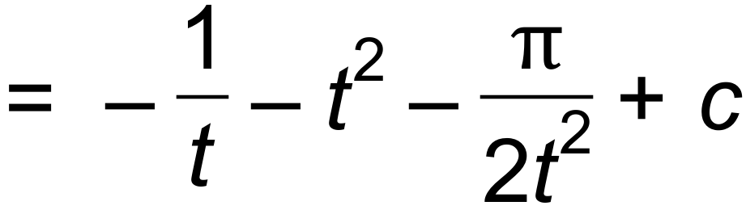 ✓✓

(b) 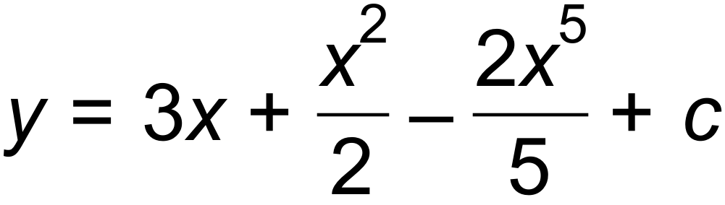 ✓

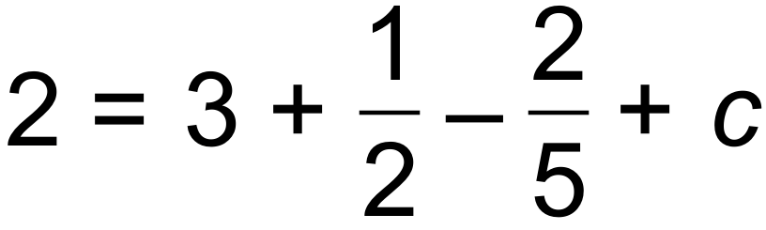

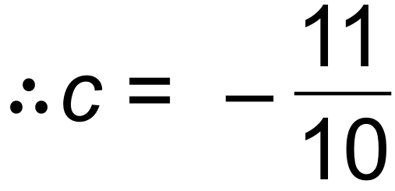 ✓

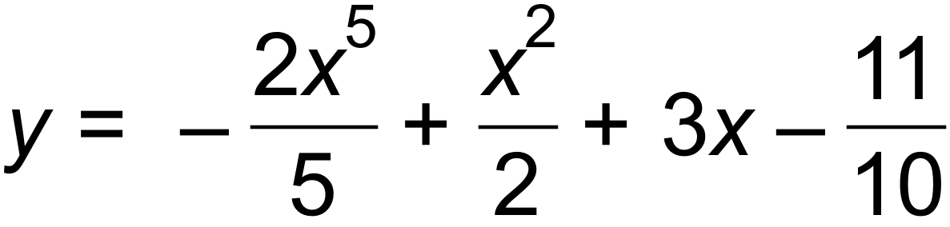 ✓ [8]

8. (a) 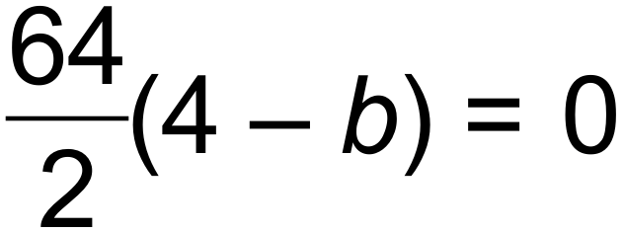

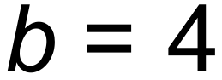 ✓

(b) 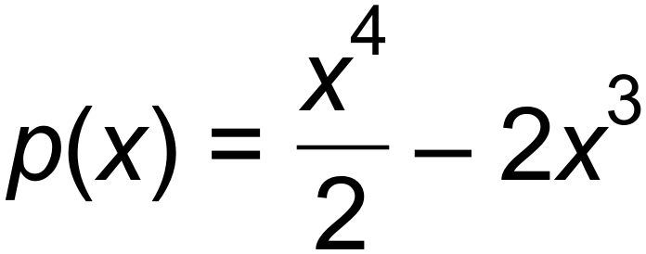

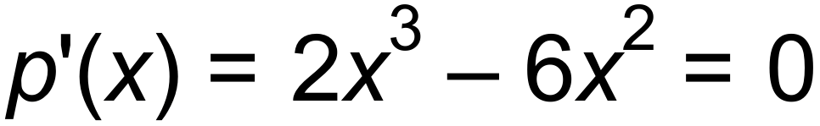 ✓

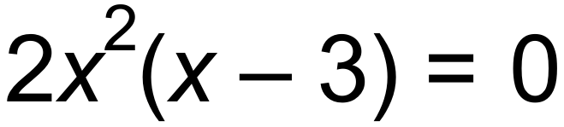

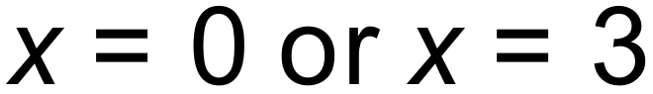 (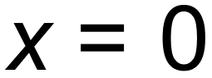 is not a minimum) ✓

When 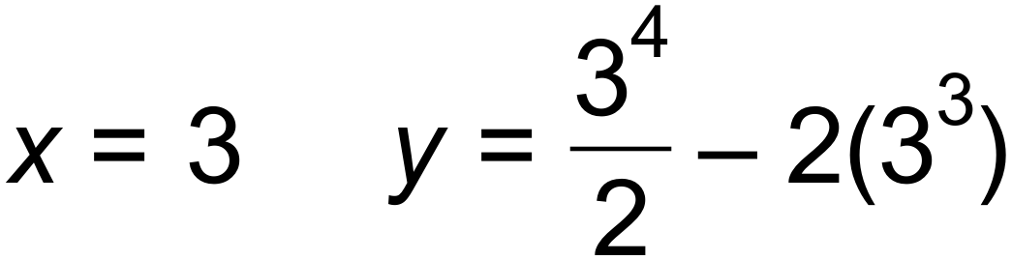

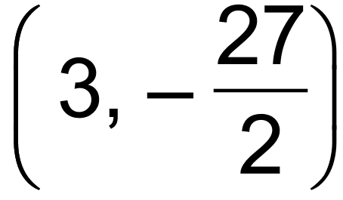 ✓

(c) Stationary point at 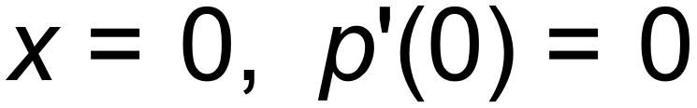

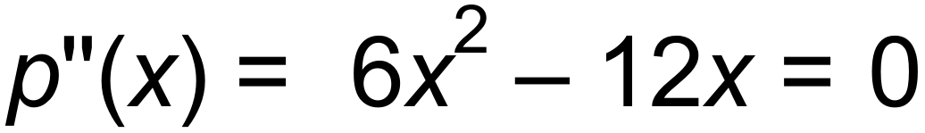 ✓

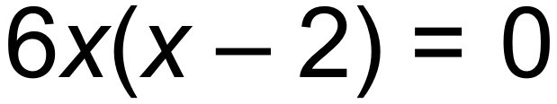

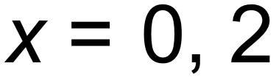

 ✓ [6]

Horizontal point of inflection

Or sign table:

|  |  |  |  |  |  |
| --- | --- | --- | --- | --- | --- |
|  |  |  |  |  |  |
|  |  |  |  |  |  |
|  | - | 0 | - | 0 | + |

9. (a) *a1* = 3

*a2* = 6

*a3 =* 10 ✓✓

(b) Tn+2 = Tn + Tn+1 T1 =1 T2 = 1 ✓ [3]

***Calculator−assumed Solutions***

10. (a) 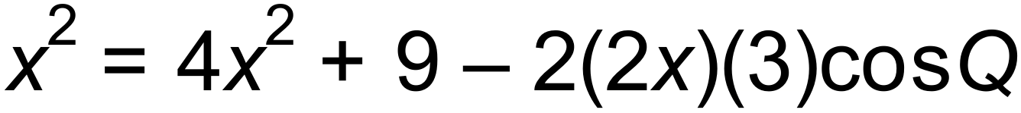

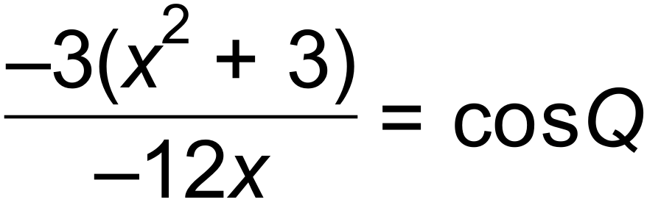 ✓

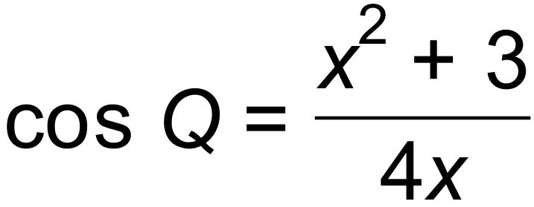 ✓

(b) cos Q = 0.9125 ✓

Q = 24.1468° ✓

Area = 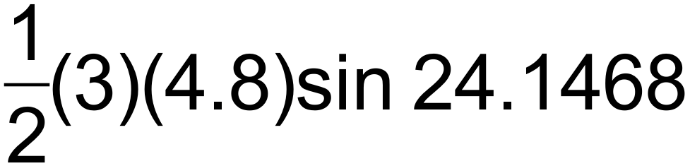

= 2.945 units2 ✓ [5]

11. (a) 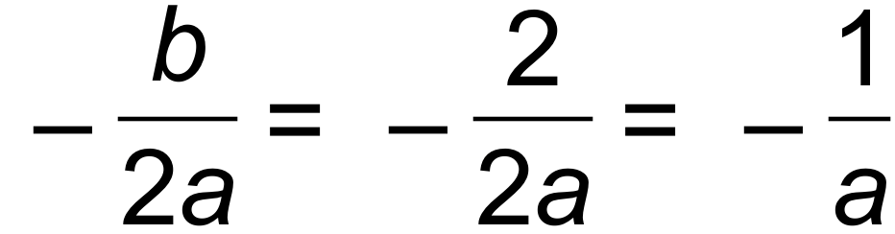

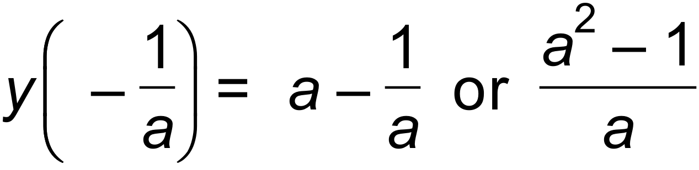

Turning point 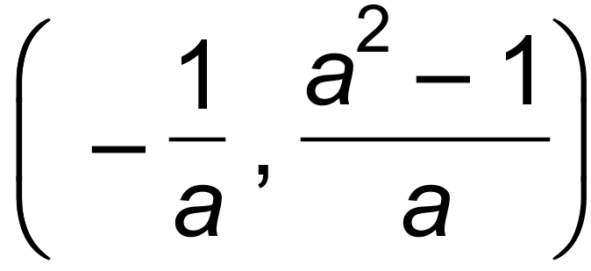 ✓✓

(b) 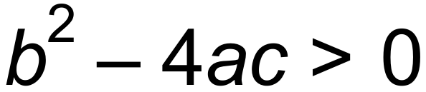

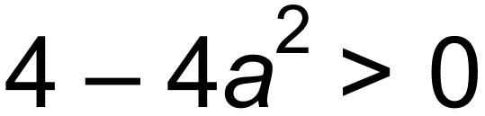 ✓

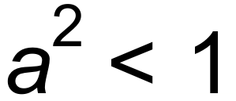

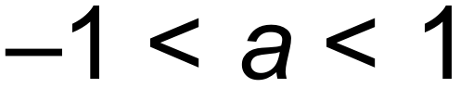 ✓ [4]

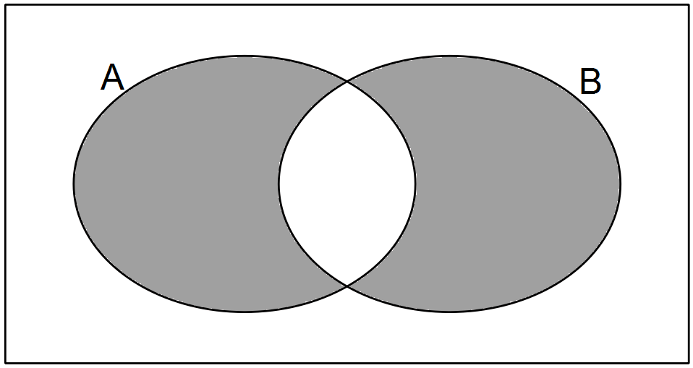12. (a)

✓

(b) (i) 0.1 ✓

(ii) 0.2 ✓

(iii) 0.3 ✓

(iv) 0.9 ✓ [5]

13. (a) 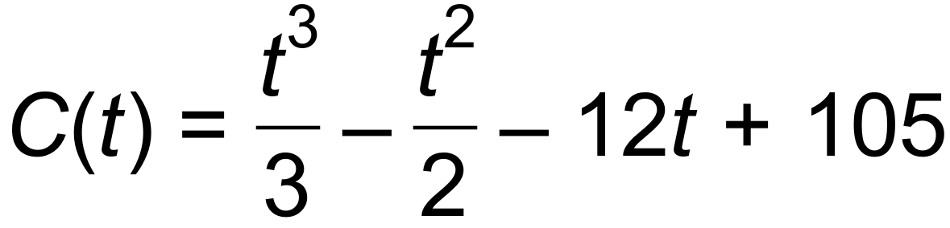 ✓

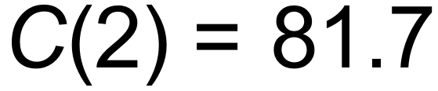 cents ✓

(b) 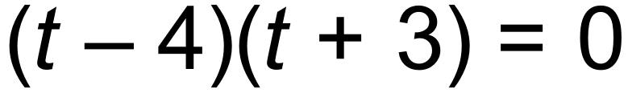

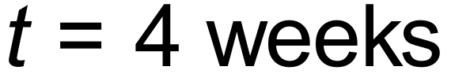 ✓

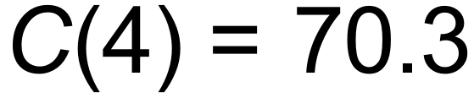 cents ✓

(c) Week 6.8 therefore during week 7 ✓ [5]

14. (a) 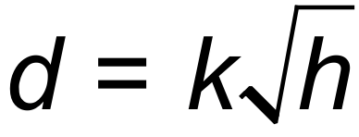

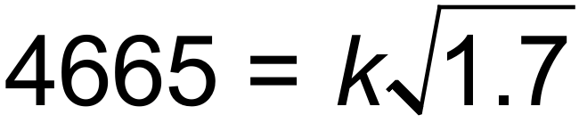

 ✓

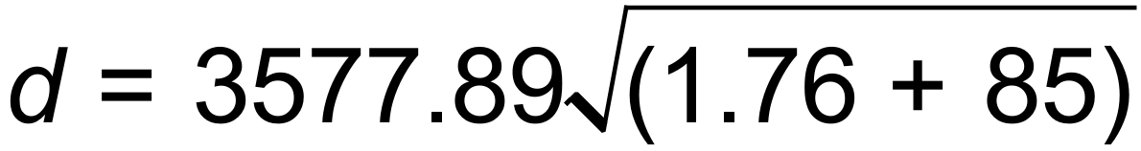

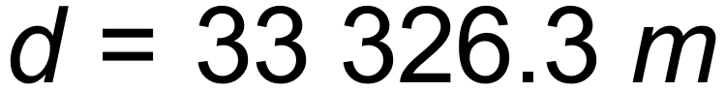 ✓

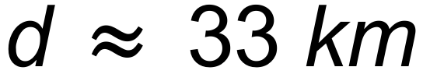 ✓

(b) 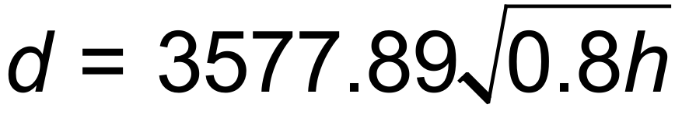 ✓

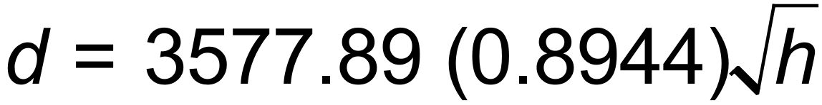

*d* decreases by 10.6%. ✓ [5]

15. (a) (i) Tn+1 = Tn + 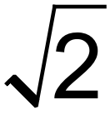 T1 = 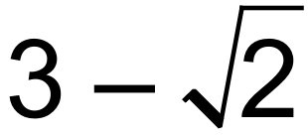 ✓✓

(ii) Tn+1 = 3 Tn T1 = 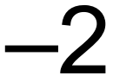 ✓✓

(b) Tn = 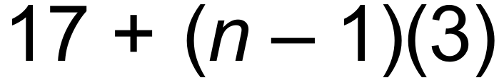 ✓

T25 = 17 + (24)(3)

= 89 ✓ [6]

16. (a)

|  |  |
| --- | --- |
| *h →* 0 | Limit = |
| 0.1 | 3.05 |
| 0.01 | 3.005 |
| 0.0001 | 3.00005 |
| 0.000001 | 3.0000005 |

✓✓

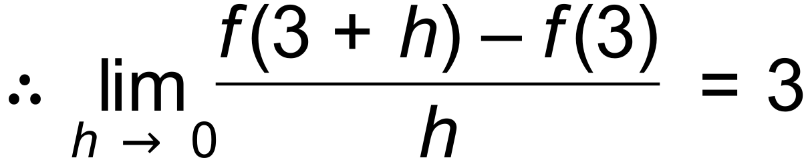 ✓

(b) 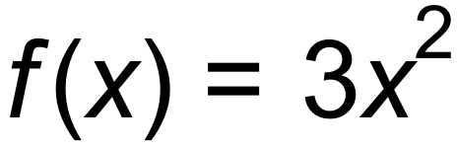 ✓

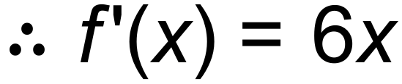 ✓

(c) 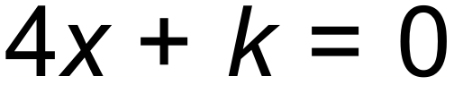 ✓

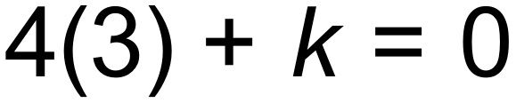

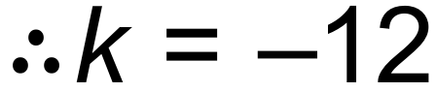 ✓

(d) 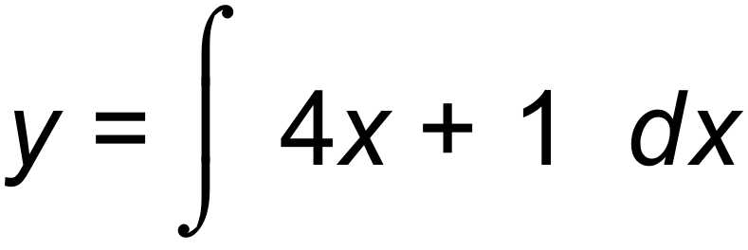

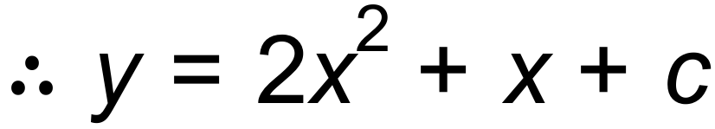 ✓

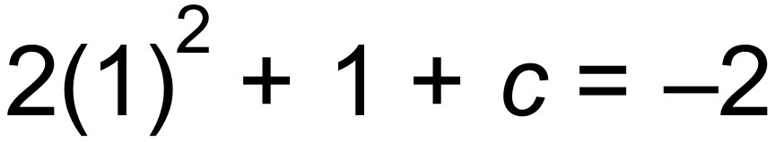

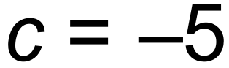

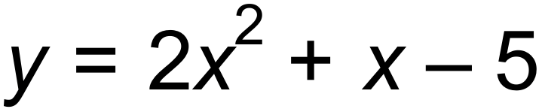 ✓ [9]

17. (a) 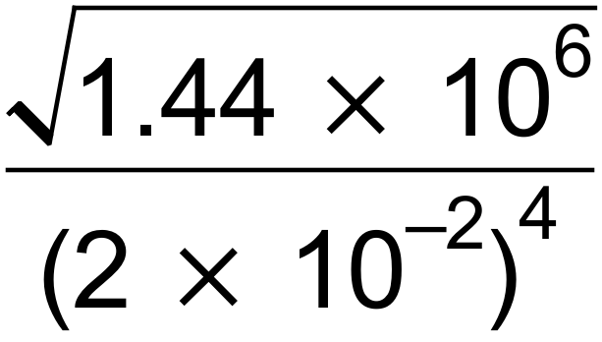

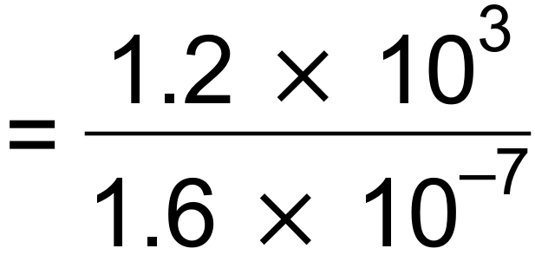 ✓

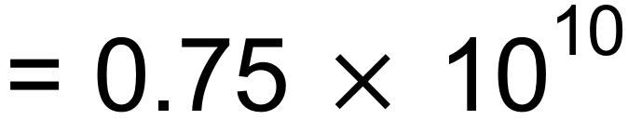 ✓

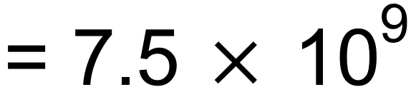 ✓

(b) (i) 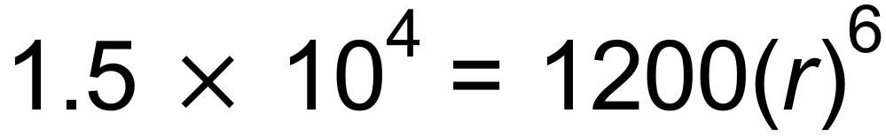

*P0* = 1200 ✓

*r =* 1.5234 ✓

(ii) *P* = 187500 ✓

(iii) 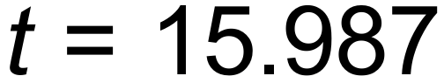 ✓

15 hours and 59 minutes. ✓ [8]

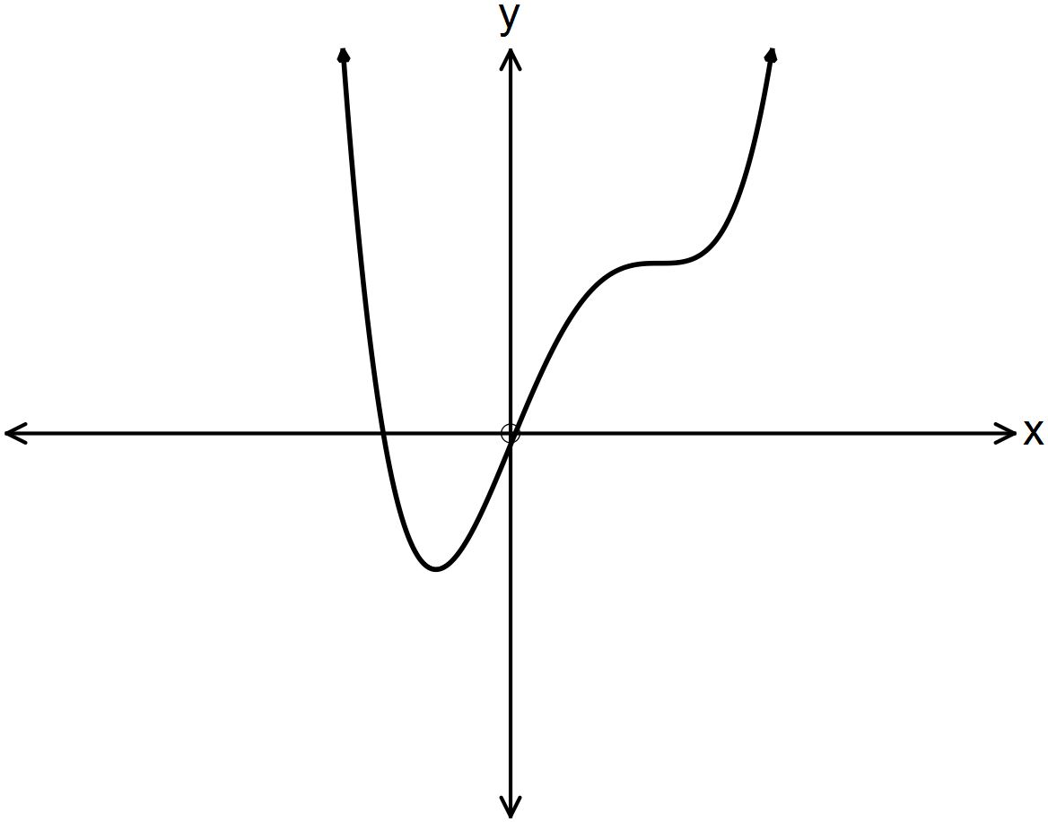18. (a)

✓✓✓

|  |  |  |
| --- | --- | --- |
| A | B | C |
| (iii) | (ii) | (i) |

(b)

✓✓✓ [6]

19. (a) (i) n = 13

T13 = 26 + (12)(2) ✓

= 50 seats ✓

(ii) n = 23 Row W ✓

(iii) n = 24

Sum of seats = 1176 ✓

(b) 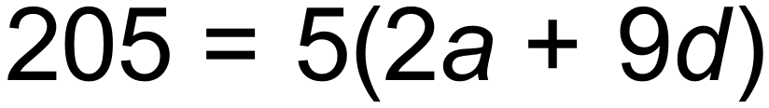

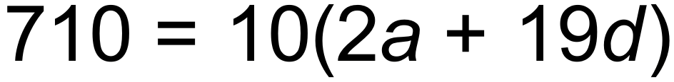 ✓

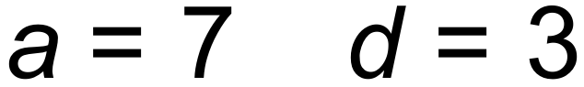 ✓

*S*30 = 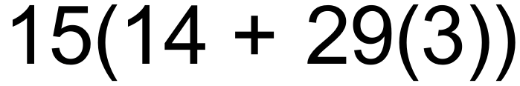

= 1515 ✓

(c) 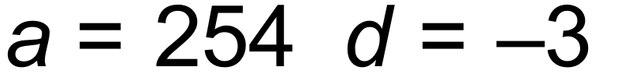 Tn = 176

176 = 254 + 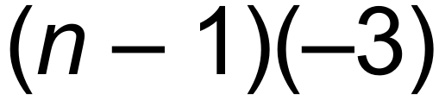 ✓

*n* = 27 ✓

*S*n  = 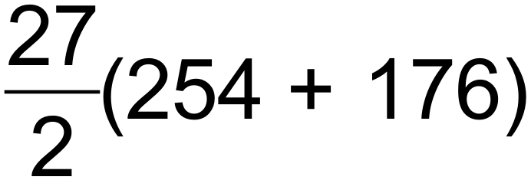

= 5805 ✓ [10]

20. (a) 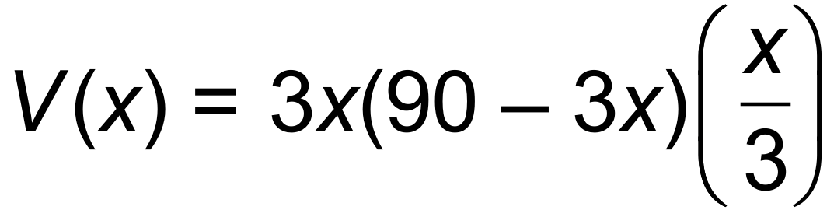 ✓

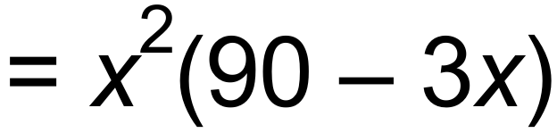 ✓

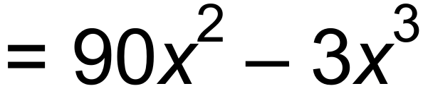

(b) 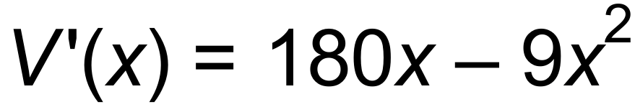

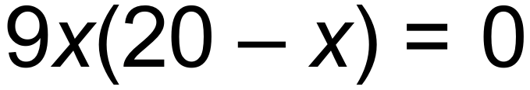 ✓

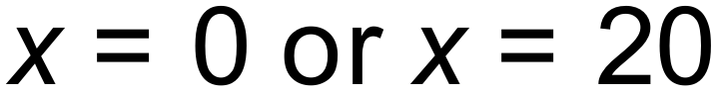 ✓

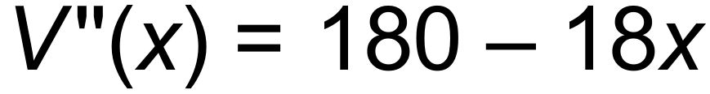  ✓

Maximum volume is 12000 *m*3

When length = 60 *m*, width = 30 *m*and depth= 6.67 *m* ✓ [6]

21. (a) (i) A1  =  A2  = 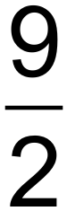 A3 = 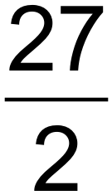 ✓

(ii) An+1  = 3 An  A1  =  ✓✓

(iii) *S25*= 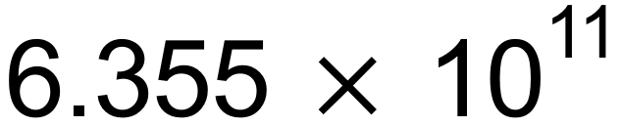 ✓✓

(b) (i) Tn = 2 T*n* – 1 T0 = 6

T12 = 24 576 users ✓✓

(ii) After 18 months ✓✓

(Or during the 18th month)

(iii) 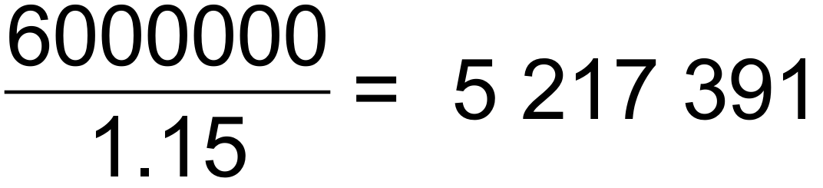 users ✓

During the 20th month ✓

(c) *S∞* = 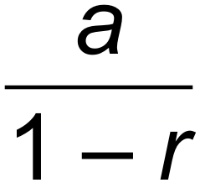

= 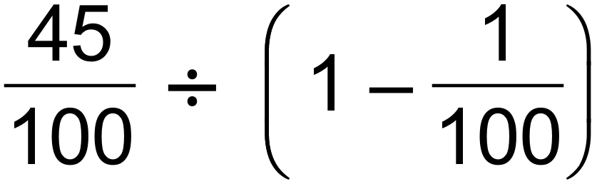 ✓

= 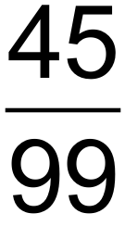

= 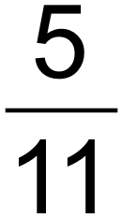 ✓ [13]

22. (a) 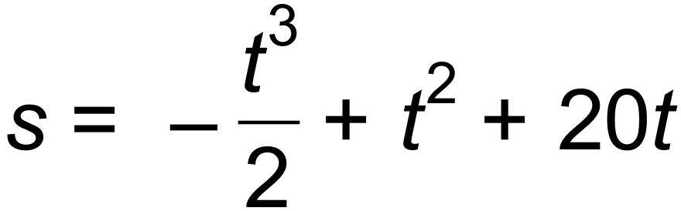. 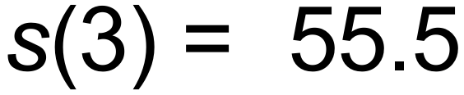 *m* ✓

(b) 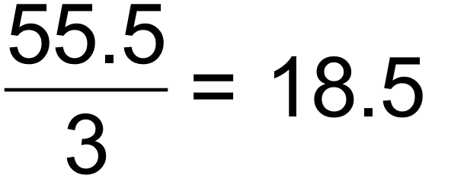*m*/*s* ✓

(c) 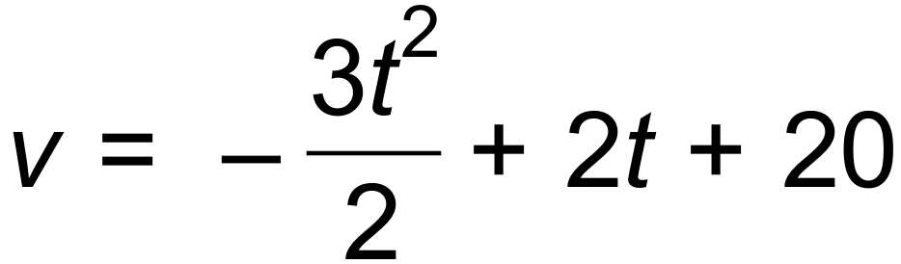 ✓

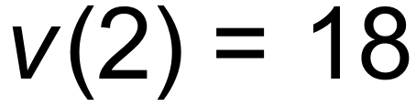 *m*/*s* ✓

(d) 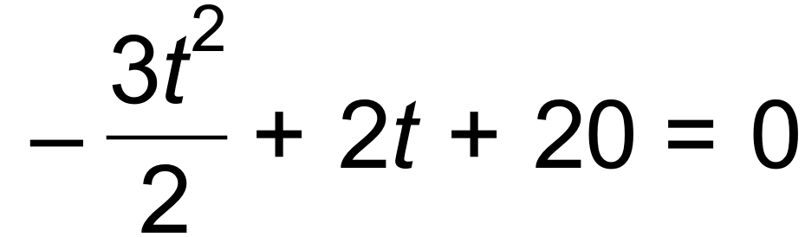 ✓

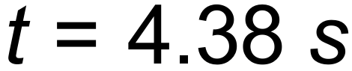 ✓

Max displacement: 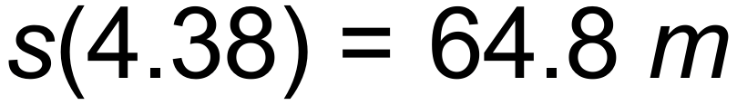 ✓

(e) 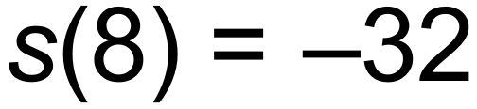 ✓

Total distance = 64.8 + 64.8 + 32 = 161.6 *m* ✓ [9]

23. (a) 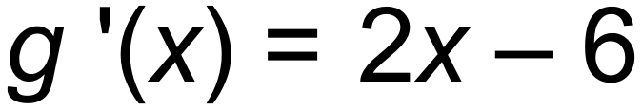

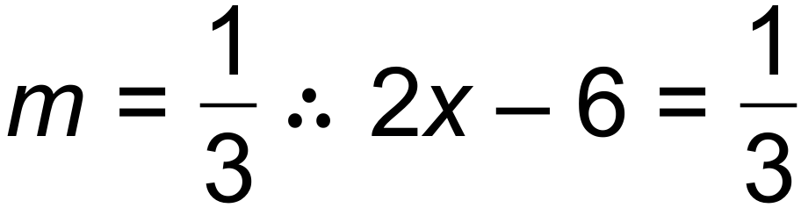 ✓

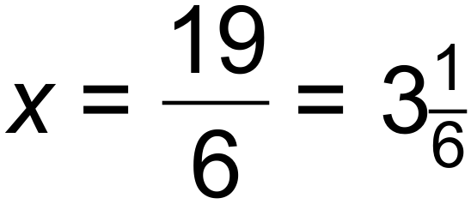 ✓

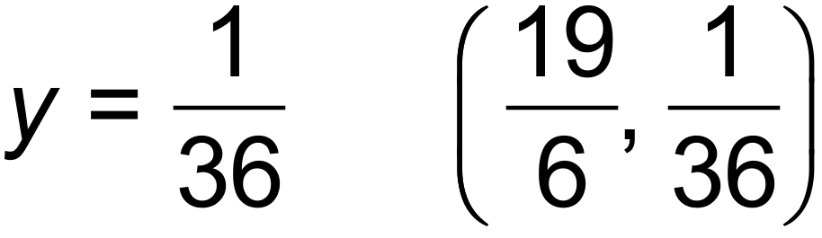 ✓

(b) (i) 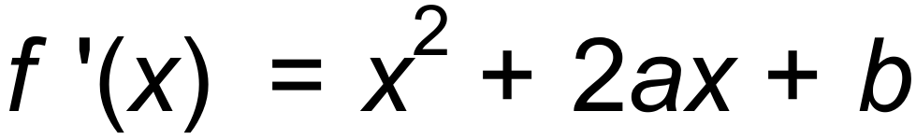

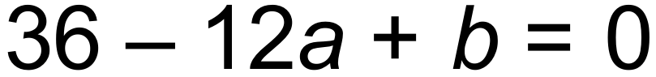 ✓

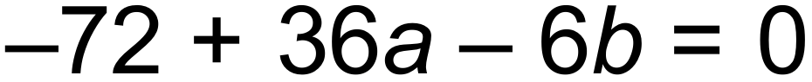 ✓

Solving simultaneously 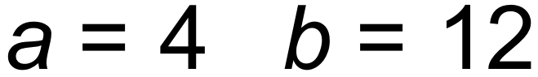 ✓

(ii) 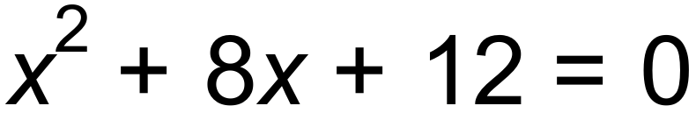

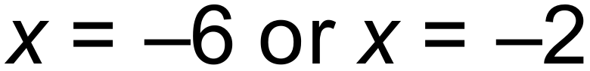 ✓

Turning point 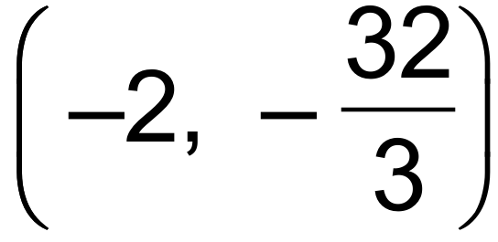 ✓

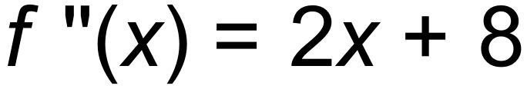 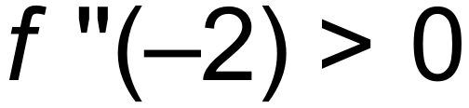 Therefore Local Minimum ✓ [9]

**End of Questions**